**DAILY ONLINE ACTIVITIES SUMMARY**

|  |  |  |  |  |  |  |  |  |
| --- | --- | --- | --- | --- | --- | --- | --- | --- |
| **Date:** | **21st may,2020** | | | | | **Name:** | **Prathusha K A** | |
| **Sem & Sec** | **4th sem &b section** | | | | | **USN:** | **4AL18CS061** | |
| **Online Test Summary** | | | | | | | | |
| **Subject** | | **Micro controller with embedded systems.** | | | | | | |
| **Max. Marks** | | **30** | | **Score** | | | **18** | |
| **Certification Course Summary** | | | | | | | | |
| **Course** | **Programming for everybody (getting started with python)** | | | | | | | |
| **Certificate Provider** | | | **Coursera** | | **Duration** | | | **7 weeks** |
| **Coding Challenges** | | | | | | | | |
| **Problem Statement: write a c program to implement SRTF process scheduling.**  **Input: A set of processes with their burst time and arrival time.**  **Output: The processes scheduled based on the arrival time and a smaller burst time.** | | | | | | | | |
| **Status: done** | | | | | | | | |
| **Uploaded the report in Github** | | | | | **yes** | | | |
| **If yes Repository name** | | | | | **https://github.com/prathu47/lockdown-coding** | | | |
| **Uploaded the report in slack** | | | | | **yes** | | | |

Online Test Details: (Attach the snapshot and briefly write the report for the same)

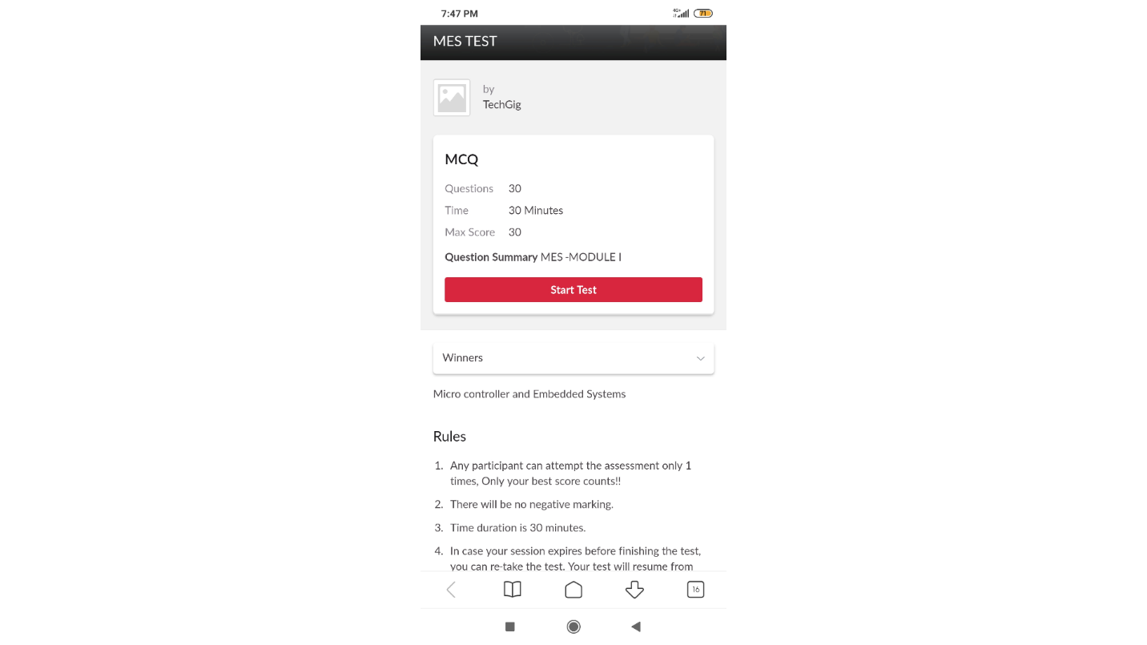

Micro controller and embedded internals was conducted today. The test was of 30 minutes,The time was not sufficient to answer all the questions. There were 30 multiple choice questions.

Certification Course Details: (Attach the snapshot and briefly write the report for the same)

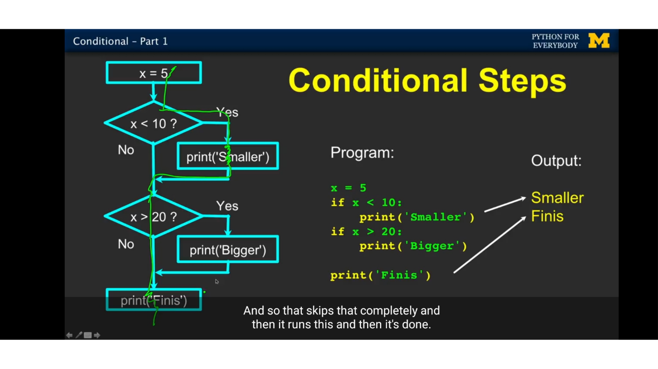

The course I have chosen during the lckdown period is programming for everybody. Since I had previously knew few topics about python iam continuing this course.Since python is gaining a lot of interest in coding platform I have preferred to choose this course.

Coding Challenges Details: (Attach the snapshot and briefly write the report for the same)

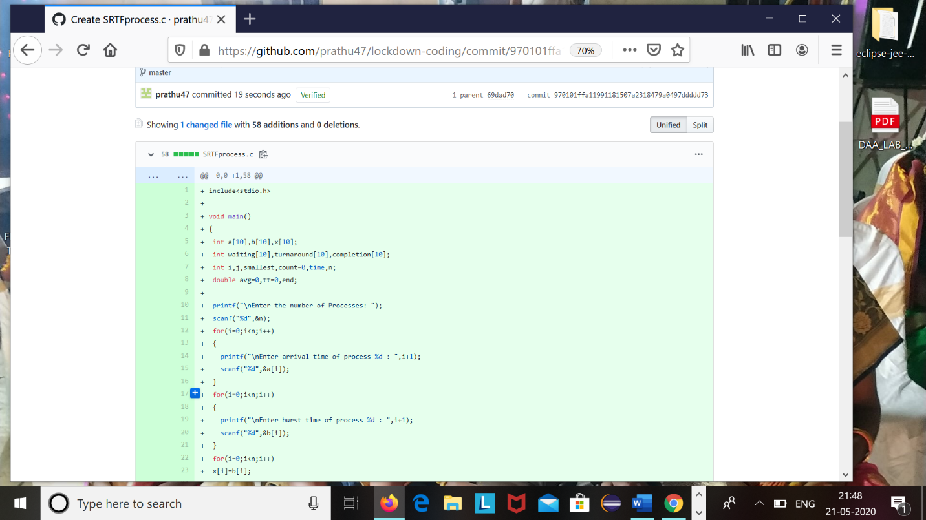

Code:The above snapshot is the code which I have uploaded in my github repository.